**MINI PROJECT – II**

**(2018-19)**

**Social Networking Site (ChitChat)**

**Group No:**

**PROJECT REPORT**



**Institute of Engineering & Technology**

**Team Members**

Nishant Jindal (161500362)

Nikhil Singhal (161500358)

Saurabh Singh (161500492)

Yogesh Bhargav (161500643)

**Supervised By**

Dr. Anand prakash gupta

**Asst. Professor**

**Department of Computer Engineering & Applications**

#### 

#### Department of Computer Engineering and Applications GLA University, Mathura

**17 km. Stone NH#2, Mathura-Delhi Road, Mathura – 281406**

### *Declaration*

*We hereby declare that the work which is being presented in the Mini Project “****Title CHIT-CHAT”,*** *in partial fulfillment of the requirements for Mini-Project LAB, is an authentic record of our own work carried under the supervision of* ***Dr. Anand Prakash Gupta, Assistant Professor, GLA University, Mathura****.*

#### Department of Computer Engineering and Applications GLA University, Mathura

**17 km. Stone NH#2, Mathura-Delhi Road, Mathura – 281406**

## CERTIFICATE

*This is to certify that the project entitled* ***“CHIT-CHAT”*** *carried out in Mini Project – I Lab is a bona fide work done by* ***Nikhil Singhal(161500358), Nishant Jindal(161500362),Saurabh Singh(161500492), Yogesh Bhargav(161500643)*** *and is submitted in partial fulfillment of the requirements for the award of the degree Bachelor of Technology (Computer Science & Engineering).*

##### Signature of Supervisor:

**Name : Dr. Anand Prakash Gupta**

**Date:05/04/2019**

**ACKNOWLEDGEMENT**

*It gives us a great sense of pleasure to present the report of the B. Tech Mini Project undertaken during B. Tech. Third Year. This project in itself is an acknowledgement to the inspiration, drive and technical assistance contributed to it by many individuals. This project would never have seen the light of the day without the help and guidance that we have received.*

*Our heartiest thanks to* ***Dr. (Prof). Anand Singh Jalal,*** *Head of Dept., Department of CEA for providing us with an encouraging platform to develop this project, which thus helped us in shaping our abilities towards a constructive goal.*

*We owe special debt of gratitude to* ***Dr. Anand Prakash Gupta,*** *Assistant Professor Department of CEA, for his constant support and guidance throughout the course of our work. Her sincerity, thoroughness and perseverance have been a constant source of inspiration for us. She has showered us with all his extensively experienced ideas and insightful comments at virtually all stages of the project & has also taught us about the latest industry-oriented technologies.*

*We also do not like to miss the opportunity to acknowledge the contribution of all faculty members of the department for their kind guidance and cooperation during the development of our project. Last but not the least, we acknowledge our friends for their contribution in the completion of the project.*

**Nikhil Singhal**

**Nishant Jindal**

**Saurabh Singh**

**Yogesh Bhargav**

# Abstract

Our project titled as “Chit-Chat” as an Web application whose purpose is to establish a network among the people residing in all over world i.e. people are able connect to each other via this application.They can easily share the information securly .Basically right now our application only contains the study material for first year students of Engineering.

A social network is a social structure that maps out the relationships between individuals. Technically we all belong to one giant social network, but we also belong to smaller, tighter social networks defined by our families, our friends, where we live, where we work, where we went to school, our hobbies and interests and much more.

Social-networking sites "make invisible social networks visible" by allowing us to see (with pictures and links) who our friends are, who our friends' friends are, and who our friends' friends' friends are -- all in an easy-to-use interface. Before you can make an online connection, you need to create a profile on a social-networking site. You'll be asked to choose a login name and password. Once you've created those, you'll be asked for some basic personal information. Your profile is the image you're presenting to the online world.

The project Social Networking Site focuses on building, developing and maintaining human relations by providing its user to have an active social life. This project is a web based application that can be accessed throughout the world and provide a variety of ways for users to interact, such as personal profiles, groups, photos, etc. Social Networking sites help users "maintain" existing (and new) offline relationships.

This site makes it easy to meet people who share your interest and hobbies. Who the user interacts with is completely user’s choice. The user can discuss current events, feedbacks and any issues through discussion forum. It is provided with graphical icons that are user friendly. A help option with a demo of how to use is provided to guide the user. Thus, allowing you to connect to your personal life and also helps you to establish new business contacts. To join this site the user needs to register and then sign-in to start connecting and experiencing a whole new world.

# Table of Contents

Declaration iii

Certificate iv

Acknowledgments v

Abstract vi

Table of Contents vii

1. **Introduction………………………………………………………………………………...8**

1.1 Objective………………………………………………………….8

1.2 Overview and Motivation………………………………………...8

1.3 Scope…………………………………………………………….. 9

1.4 Limitation of the Project………………………………………….9

1. Feasibility Study……………………………………………………….10
   1. Technical Feasibility
   2. Economical Feasibility
   3. Operational Feasibility
   4. Managerial Feasibility
2. System Analysis………………………………………………………11
3. Project Architecture………………………………………………….12
   1. Data Flow Diagram…………….………………………...12
   2. Entity Relational diagram………………...……………...15
   3. Database Diagram……………..………………...……….17
   4. Sequence Diagram ………………………………….…...18
4. Implementation and User Interface…………………………………19
5. Testing………………………………………………………………...33
   1. Introdution to Testing………………………………………….. 33
   2. Objective………………………………………………………...33

6.2.1 Unit Testing……………………………………………… 33

6.2.2 Integreation Testing……………………………………….34

6.2.3 System Testing………………………………...………….34

6.2.4 User Acceptance…………………………………...……...34

##### Non Functional Requirement………………………………………………….38

##### Performance………………………………………………………………….. 38

##### Security………………………………………………………………….………..38

##### Software Quality Attribute Requirement………………….…….. 38

##### Conclusion…………………………………………………………….……………..…40

##### Appendices……………………………………………………………….…………...41

##### Coding… …………………………………………………………….…………...41

##### Defination and acronyms……………………………….………………. 42

##### Bibliography…………………………………………………………………... 43

1.INTRODUCTION-

1.1 OBJECTIVE-

The objective of this project Social Networking Site is to connect user. Social networks rightly defined as "our connections with other people".

• Provide easy to create and share a personal profile for users.

• Easy search out and contacting potential friends in the network.

• Easy to form community and start a discussion

The project Social Networking Site is aimed at developing and maintaining human relations by providing its user to have an active social life. This project is an Internet based application that can be accessed throughout the world helps you maintain existing relations and also establish new ones. This is made possible by messages, pictures and many more.

This site makes it easy to meet people who share your interest and hobbies. Who the user interacts with is completely user’s choice. The user can discuss current events, feedbacks and any issues through discussion forum. It is provided with graphical icons that are user friendly. A help option with a demo of how to use is provided to guide the user.

Thus, allowing you to connect to your personal life and also helps you to establish

new business contacts. To join this site the user needs to register and then sign in to start connecting and experiencing a whole new world.

**1.2 Overview and motivation-**

The main goal of the service is to make your social life and that of your friends, more active and stimulating. Social network can help you both maintain existing relationships and establish new one s by reaching out of people you have never met before. Before getting to know a forever member, you can even see how they are connecting you through the friend’s network.

This software is provided as an online only resource so that it may be continually extended and updated.

In the early days of the web, in 1994 and 1995, several people were working on enabling email to be accessed on a web browser. In Europe, Soren Vejrum and Luca Manunza released their "WWW Mail" and "WebMail" applications, whereas in the United States, Matt Mankins wrote "Webex".

The term Webmail (or Web-based e-mail) is used to describe two things.

1.To describe a Webmail client: an email client implemented as a web application accessed via a web browser.

2.To describe a email service offered through a web site (a webmail provider) such as Hotmail, Yahoo! Mail, Gmail, and AOL Mail;. Practically every webmail provider offers email access using a webmail client, and many of them also offer email access by a desktop email client using standard email protocols, while many internet service providers provide a webmail client as part of the email service included in their internet service package.

**1.3 Scope-**

It allows users to connect with their friends and family through a common platform. Furthermore, users can share their posts and message with friends. These chats can be saved or deleted as per the user’s wishes. Users can also maintain, update or delete their account.

It is a web-based application.

• Users can upload images.

• Discussion forum is provided.

• Registration/Login facility.

• Help Desk for better understanding.

• Open community like module is available.

**1.4. LIMITATION OF A PROJECT**

The main limitation of the project is for everyone and thus does not restrict anyone from entering. Yet, this can be modified as per requirement. The project is in initial stages and needs to evolve.

There are a number of major issues that have surfaced and need to be addressed by organizations as they consider moving forward into the realm of social networking. These include:

• Privacy & Security - On large social networking services, there have been growing concerns about privacy and users giving out too much personal information. Who has access to this information and what abuses may occur must be considered? When partnering with users on social networking site, only the most trusted users must be accepted.

• Legal Issues - Corporations moving into social networking may be putting themselves at risk. There are a range of legal and liability issues that must be addressed before moving forward. Corporate policies need to be developed to provide guidance and set some needed boundaries

• Education & Research - It is still very early to talk about. More research and evaluation of social media environments is needed. The education of potential users about social networking media and instructions and how to take advantage of it should be provided.

• Fake Identity - In the virtual world of online communities it is hard to prevent someone from creating a fake personality. This could mean a less trustworthy user in the network.

**2. FEASIBILITY STUDY-**

Once the system objectives have been ascertained by initial investigation, we need to spell the various possible solutions to meet the various objectives. The feasibility study is conducted to check whether the candidate system is feasible. The system which is selected to be the best against the criteria is thereafter designed and developed. The feasibilitystudy takes into consideration. The risks involved in the project development beforehand.Feasibility study includes seven distinct but inters related type of feasibility.All these feasibility study used by us.

**2.1 TECHNICAL FEASIBILITY-**

Focus is on establishing whether the technology needed for the proposed system is available and how this technology can be integrated within the organization. Technologies include are:

· Hardware

· Software

· Application developed environment

**2.2 ECONOMIC FEASIBILITY-**

It is concerned with the returns or benefits of the organization are likely to derive from investment in the system. Estimated costs of new system development and operation must be balanced against projected tangible as well as intangible benefits.

**2.3 OPERATIONAL FEASIBILITY-**

It is an evaluation to determine whether a system is operationally acceptable. Two impotent dimensions to be accessed are ability and motivation to use the system.

**2.4 MANAGERIAL FEASIBILITY-**

It determines whether a proposed system will be acceptable to the people or not. It also determines from the management.

**3.SYSTEM ANALYSIS**

System Analysis and Design, is the process of gathering and interpreting facts, diagnosing problem and using the information to recommend improvement to the system. Before development of any project can be pursued, a system study is conducted to learn the details of the current business solution. Information gathered through the study forms the basis for creating alternative design strategies .Virtually all organizations are systems that interact with their environment through receiving input and producing output.

It is a management technique used in designing a new system, improving an existing system or solving problem .System analysis does not guarantee that the user will derive an ideal solution to a problem .This depends solely on the way one design a system to exploit the potential in the method To put it in another way, creativity is as much as must pre-design the study and problem solving process and evaluates every successive step in the system analysis.

Taking all these factors into account and with the knowledge of the Inter -relationship between the various fields and section and their potential interactions, they are consider for developing the whole system in and integrated manner .

The management technique is also helps us in develop and design of the new system or to improve the existing system..

**The following Objectives are kept in mind:**

**1.** Identify the customer’s need.

Evaluate the system concept for feasibility.  
**** Perform economic and technical analysis.

**** Allocate functions to hardware, software, people, database and other system elements .

**** Establish cost and schedule constraints

****  Create a system definition that forms the foundation for all subsequent engineering work.

* Recording requirements: Requirements might be documented in various forms, such as natural-language documents, [use cases](http://en.wikipedia.org/wiki/Use_case) , [user stories](http://en.wikipedia.org/wiki/User_story), or process specifications.

**4 . Project architecture-**

After gathering the requirements and determining that the proposed system is technically feasible, we will move further towards the designing issues.

Here the main goal is to transform the requirements specification into a structure that is suitable for implementation in some programming language.

Here we determine the individuals constraints to be used further as per requirements.

These constraints are than mapped into DATA FLOW DIAGRAMS(DFD)

& ENTITY RELATIONSHIP DIAGRAM(ER-DIAGRAM).

In this chapter we will present the DFDs and ER-DIAGRAMs of the entities like general detail of user, professional details, login details, personal details of user and many more.

**4.1 DATA FLOW DIAGRAMS(DFDs)-**

Data flow oriented techniques advocate that the major data items handled by a system must be first identified and then the processing required on these data items to produce the desired outputs should be determined. The DFD (also called as bubble chart) is a simple graphical formalism that can be used to represent a system in terms of input data to the system, various processing carried out on these data, and the output generated by the system. It was introduced by De Macro (1978), Gane and Sarson (1979).The primitive symbols used for constructing DFD’s are:

**Symbols used in DFD**

A *circle* represents a process.

A *rectangle* represents external entity

A *square* defines a source or destination of the system data.

An *arrow* identifies dataflow.

**4.1.1 0 Level DFD:** A level 0 DFD, also called a fundamental system model or context diagram represents the entire software element as a single bubble with input and output data indicated by incoming and outgoing arrows, respectively.

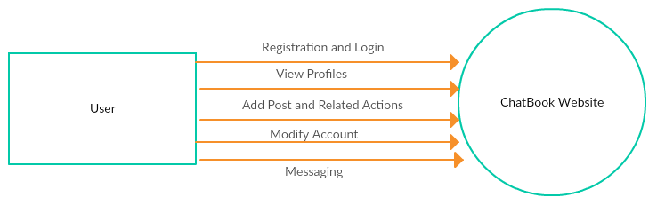

CHIT-CHAT

**Fig 4.1.1.- 0 Level DFD**

**4.1.2 1 Level DFD:** This level of DFD provide more detailed structuare.it provides a detailed view of requirements and flow of data from 1 bubble to another.

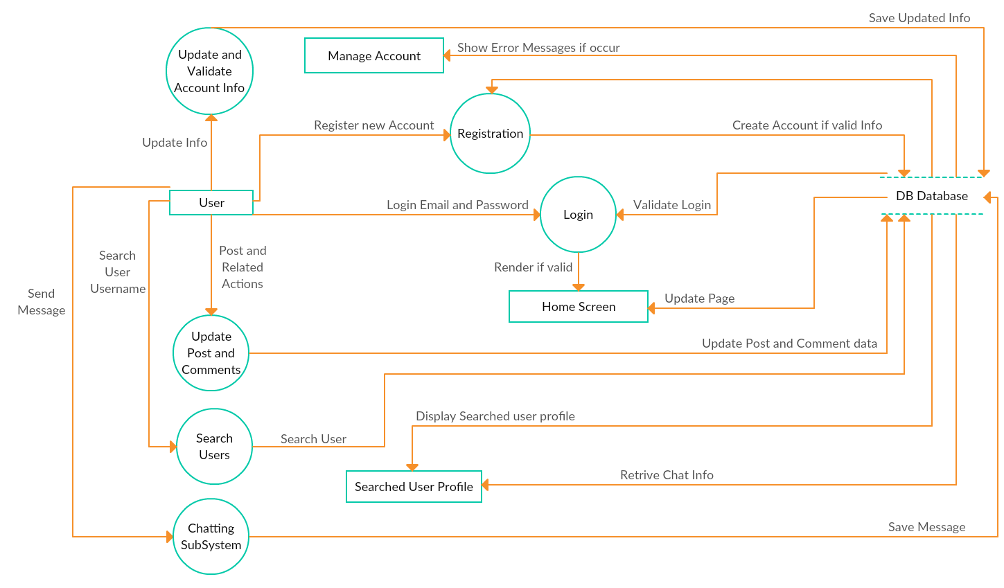

**FIG 4.1.2 LEVEL 1 DFD**

**4.2 ENTITY RELATIONSHIP DIAGRAM**

The entity relationship model is a high level data model. It is based on a perception of a real world that consists of a collection of basic objects, called entities, and of relationship among these objects. It was developed to facilitate database design by allowing specification of an enterprise schema, which represent the overall logical structure of a database.

**Entity:** An entity is an object that has its existence in the real world. It includes all those “things” about which data is collected. An entity may be a tangible object such as a student, a place or a part. It may also be non-tangible such as an event, a job title or a customer account. For example, if we say that a customer buys goods, it means customer and goods are entities.

Diagrammatically, entities are represented in rectangles.

**An Entity Set**: It is a set of entities of the same type that share the same properties, or attributes. The set of all persons who are customers at a given bank, example, can be defined as the entity set customer.

**Attributes**: Attributes are units that describe the characteristics or properties of entities. In a database, entities are represented by tables and attributes by columns. For example, a customer entity might have numerous attributes such as code, name and addresses. Similarly, the goods entity may have attributes like code and price. They are drawn in elliptical shapes along with the entity rectangles.

The entity relationship diagram of mailing system is drawn:

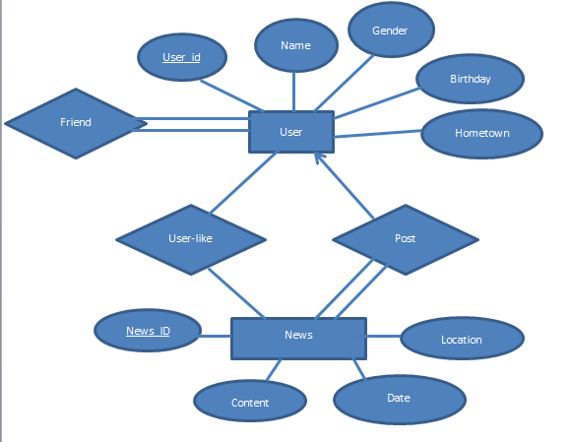

**Fig:Entity relational diagram**

**4.3 Database design**

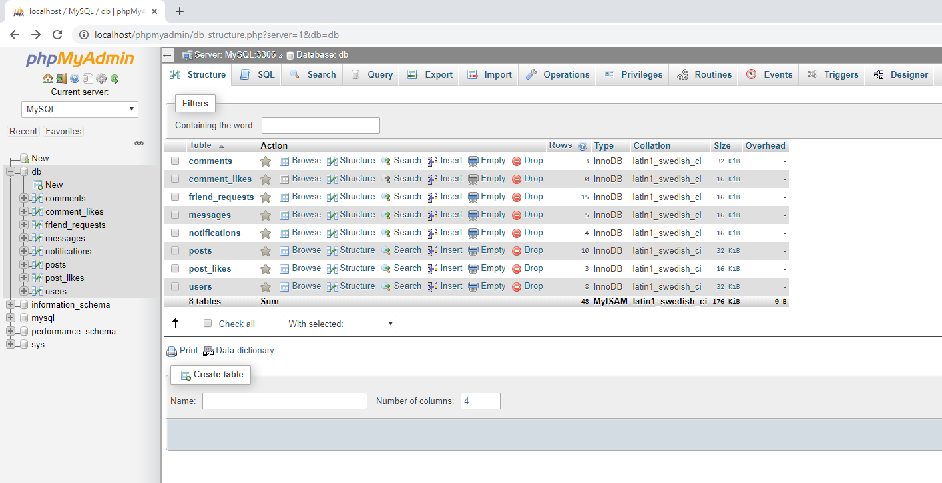

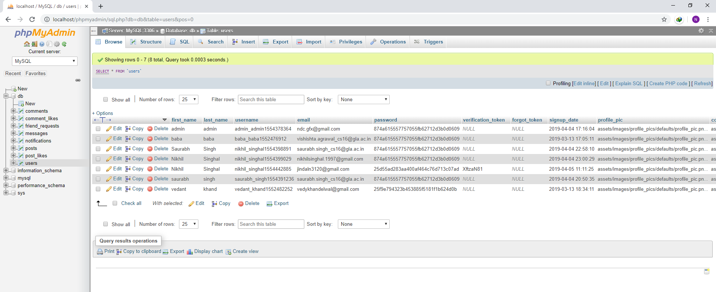

**4.4 Sequence Diagram:**

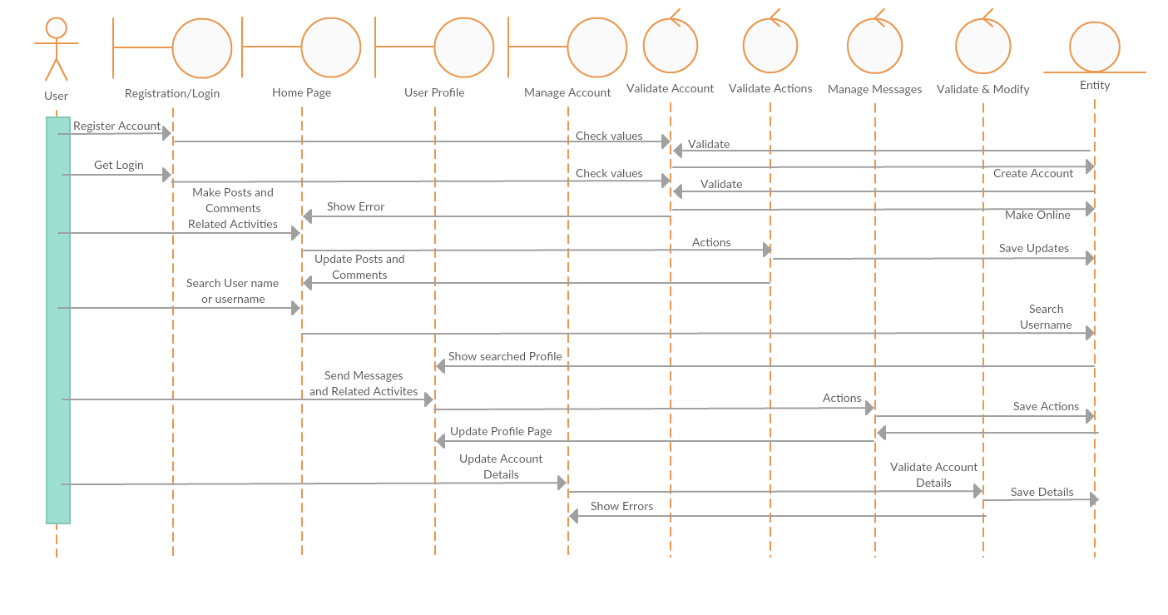

**Fig4.4.1:Sequence diagram**

**5. Implementation and user Interface**

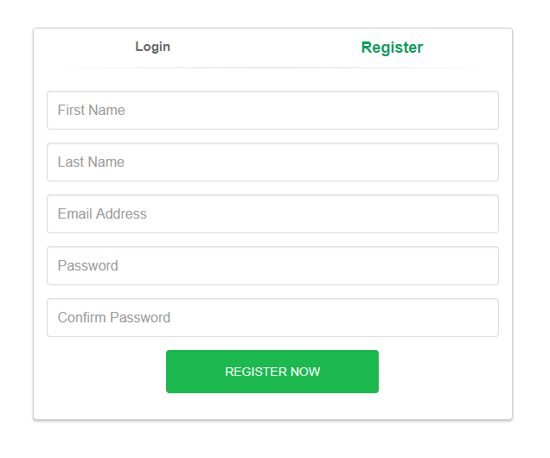

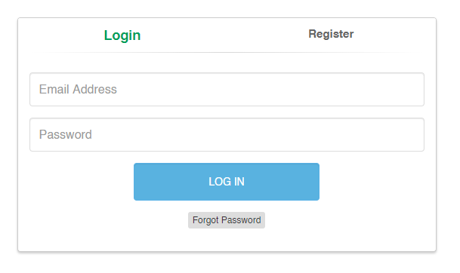

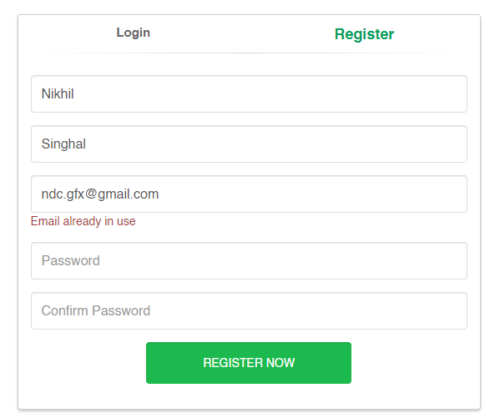

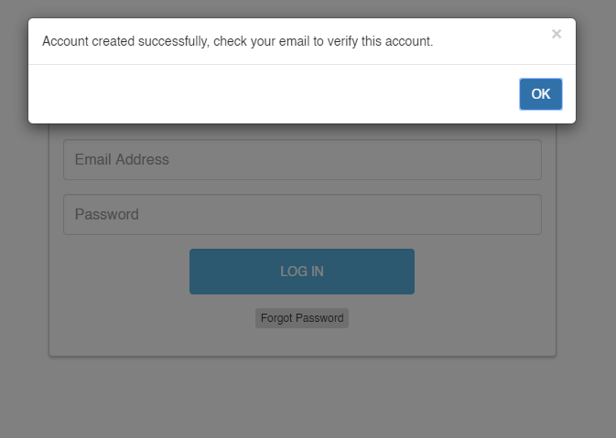

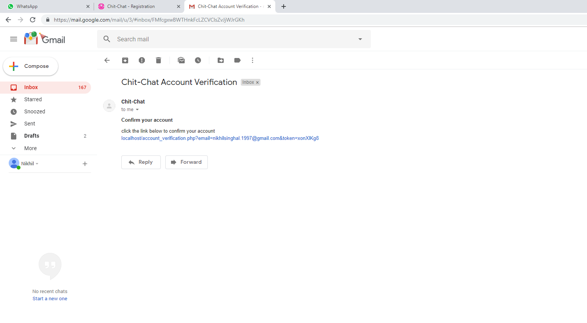

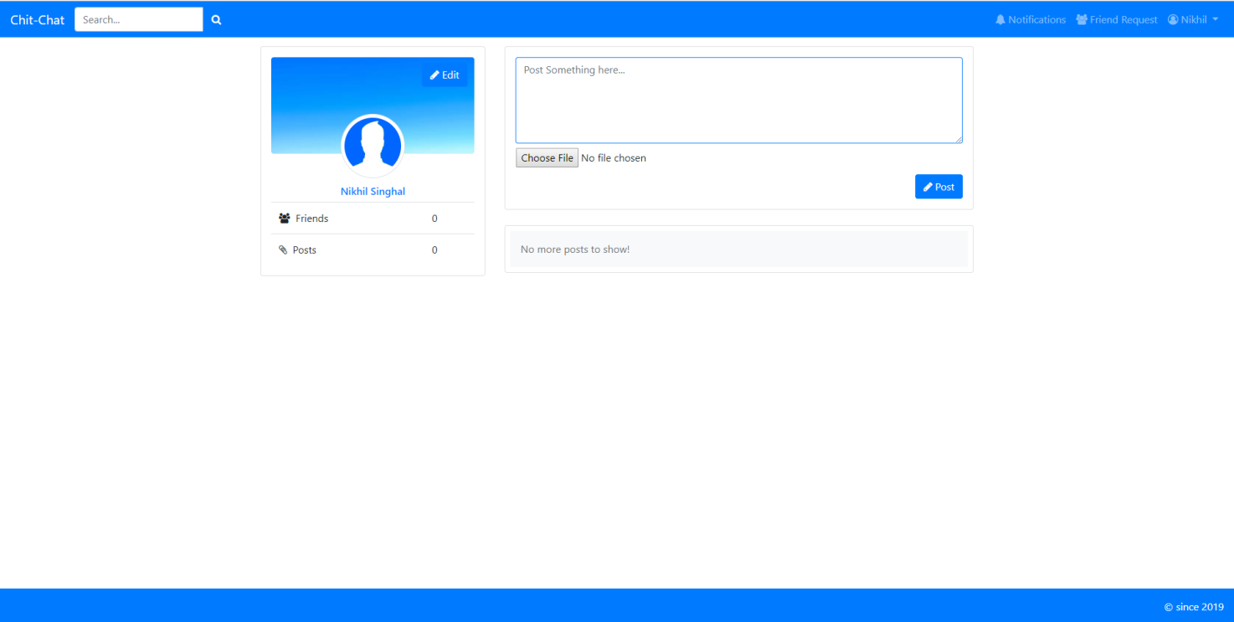

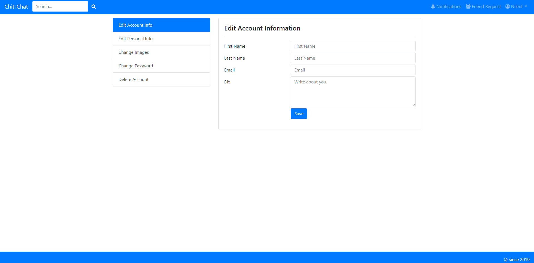

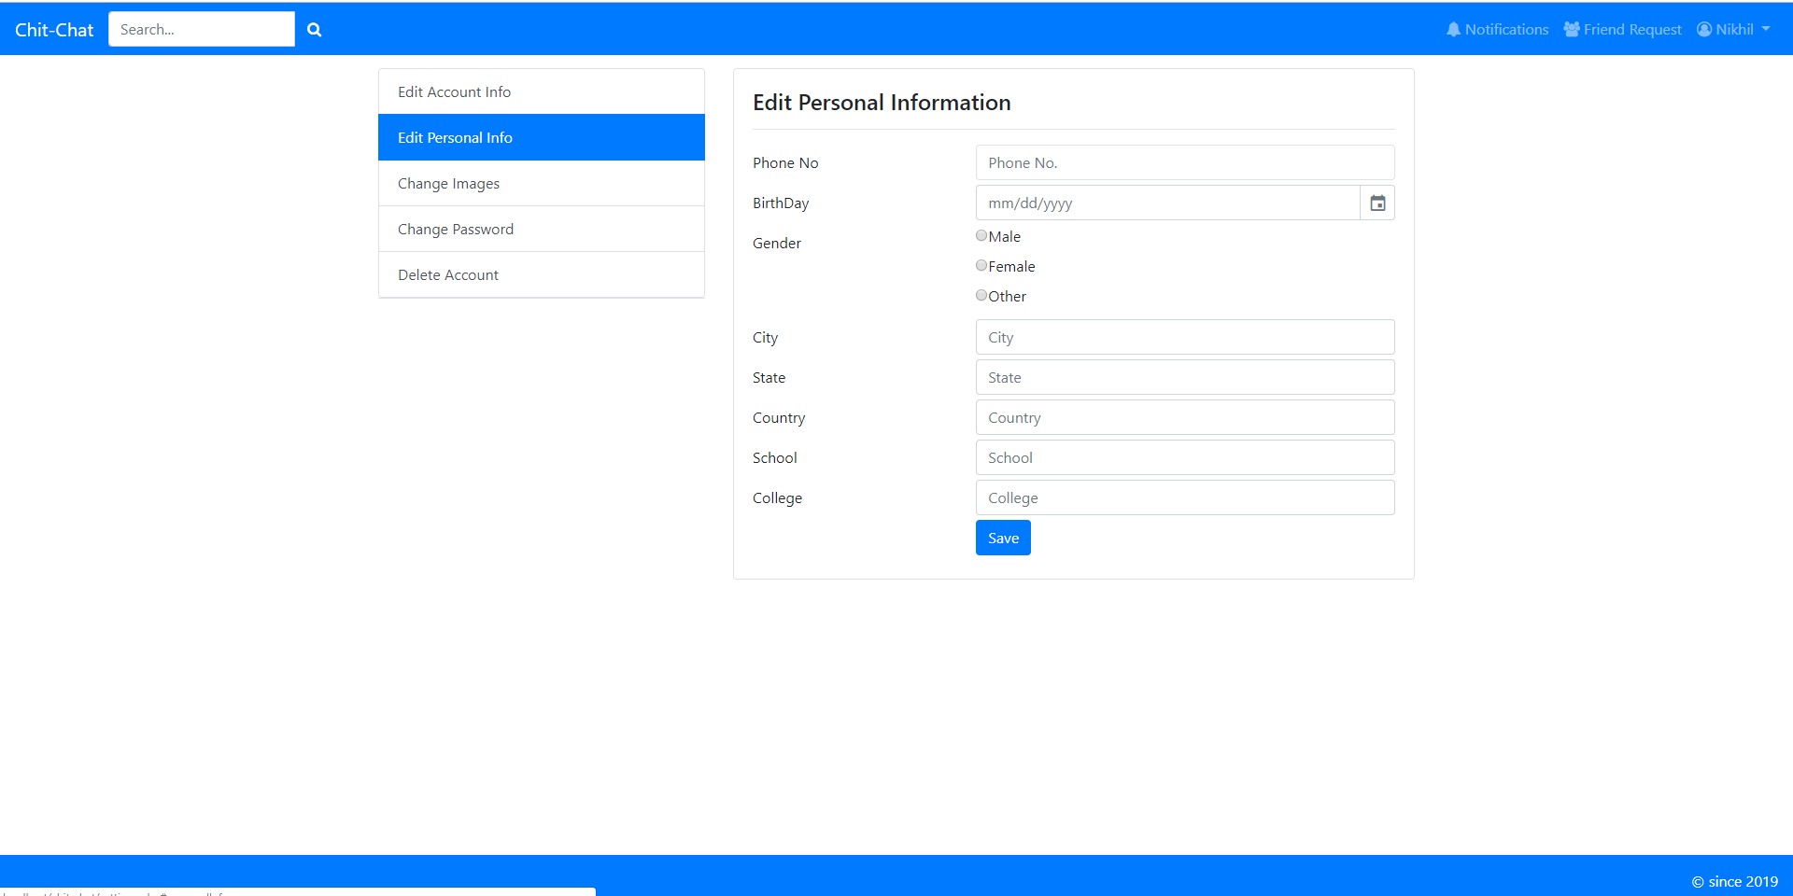

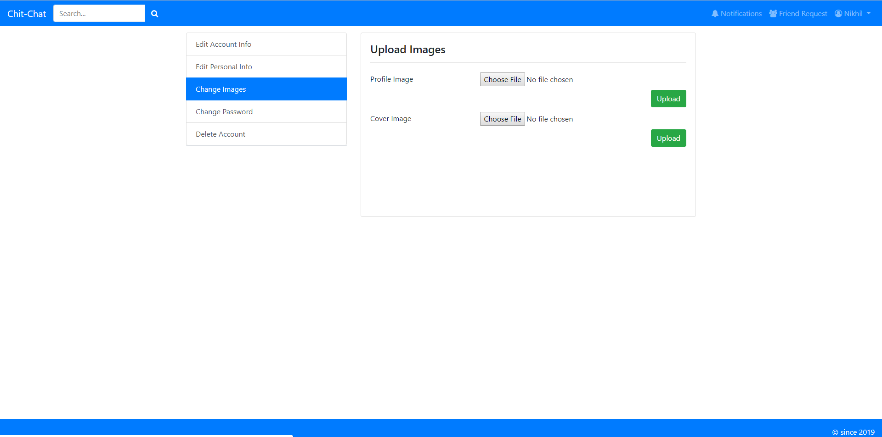

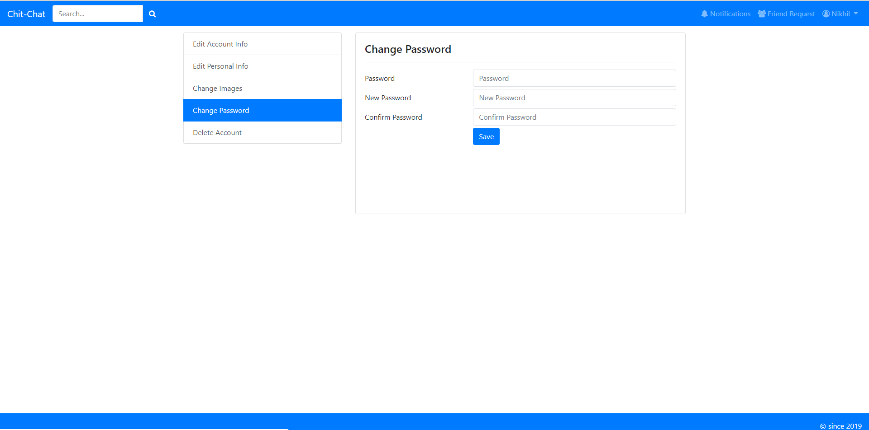

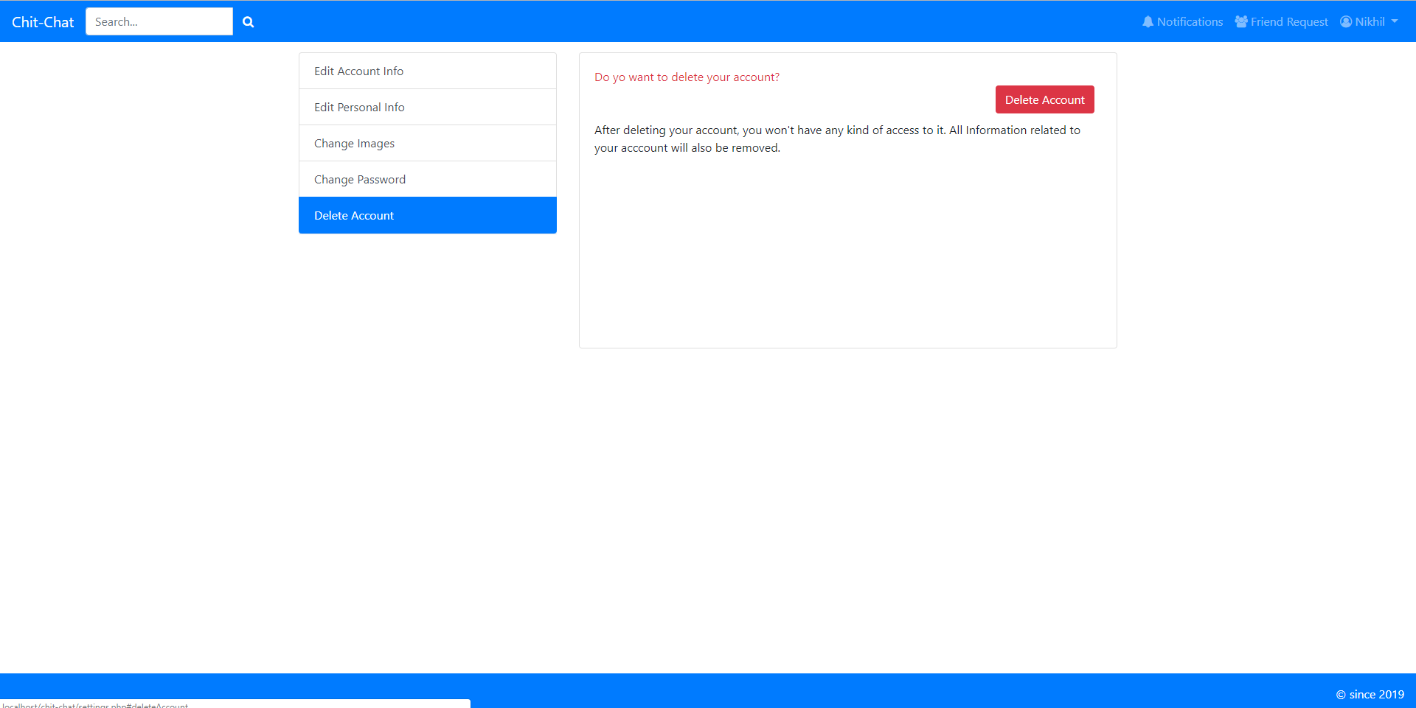

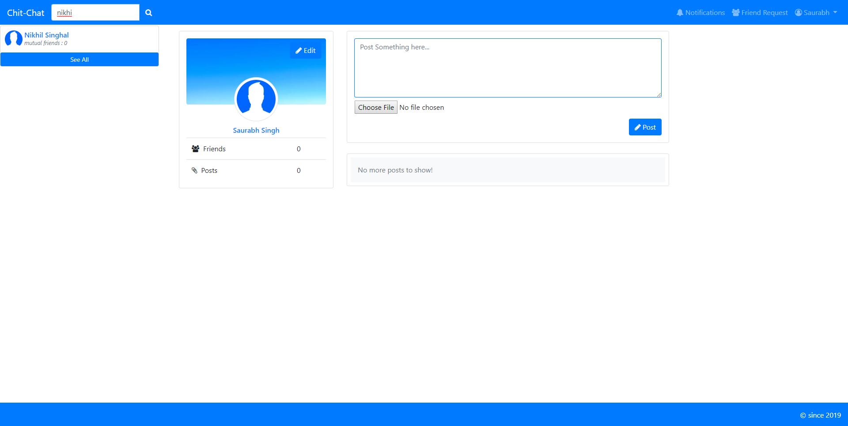



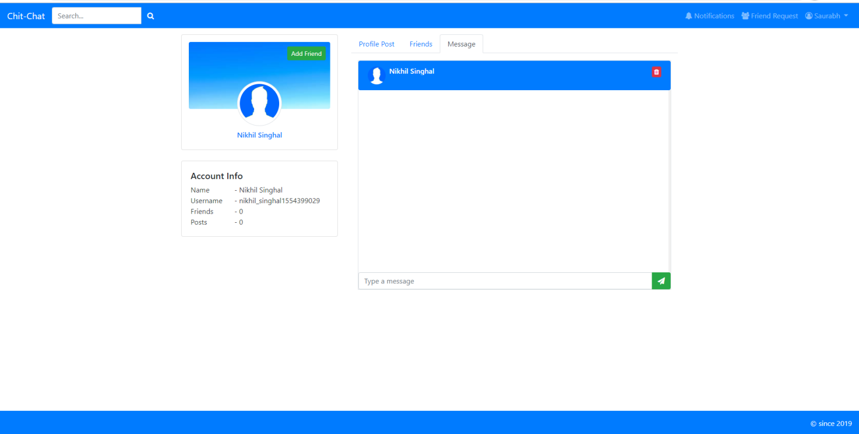

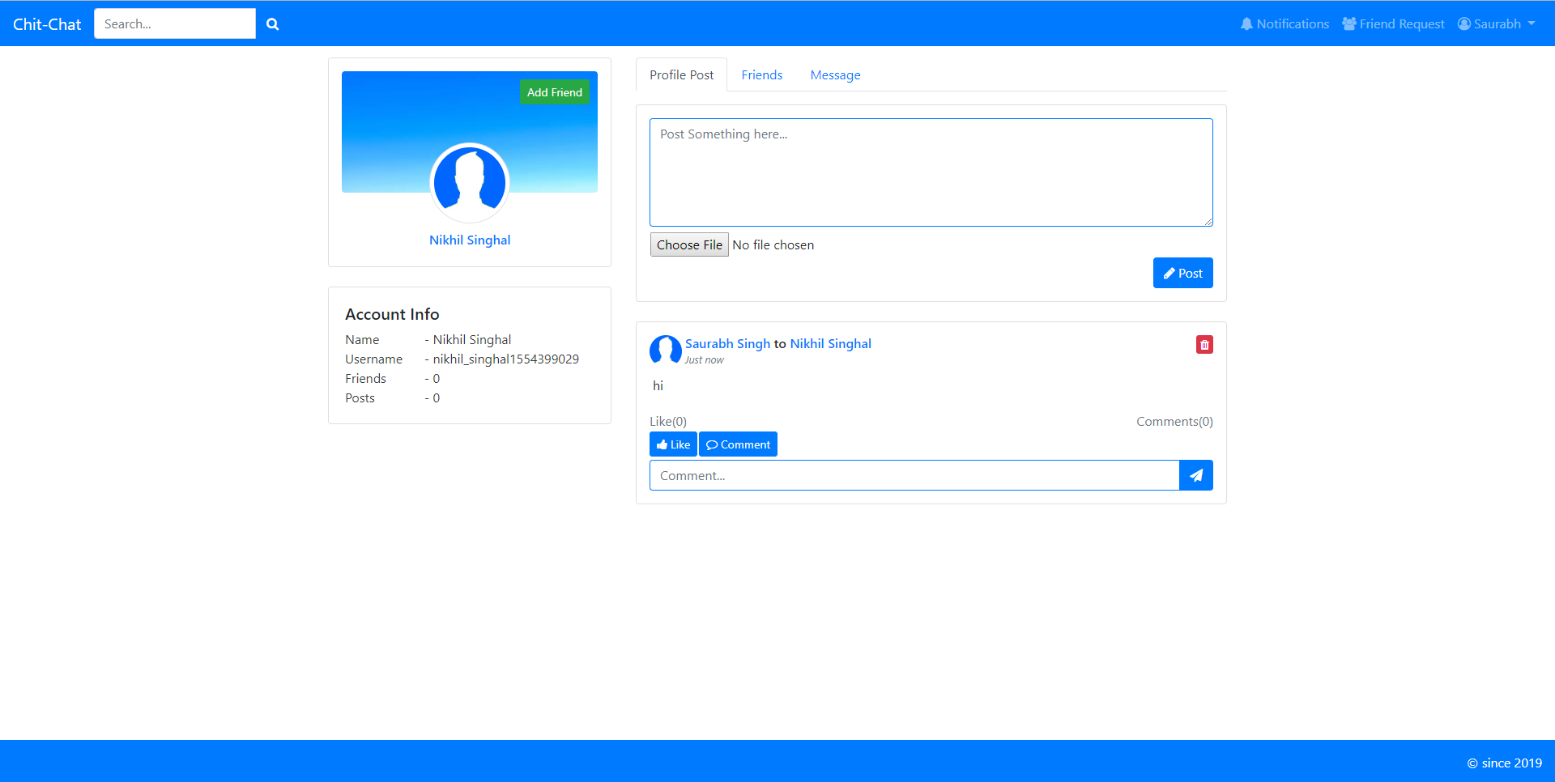

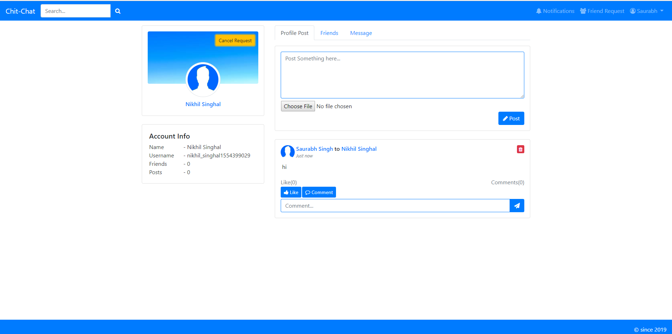

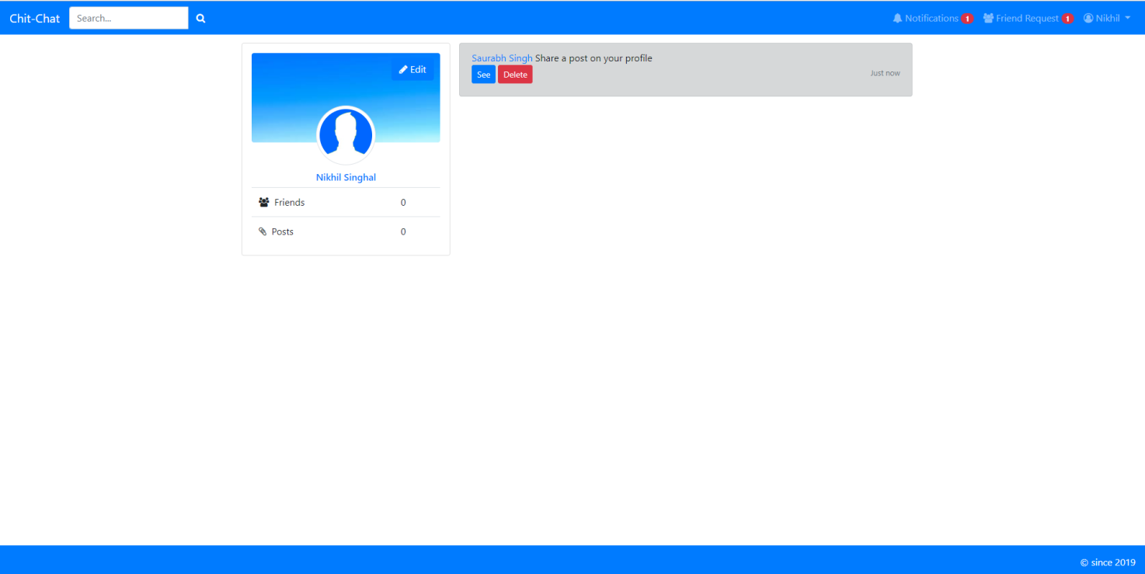

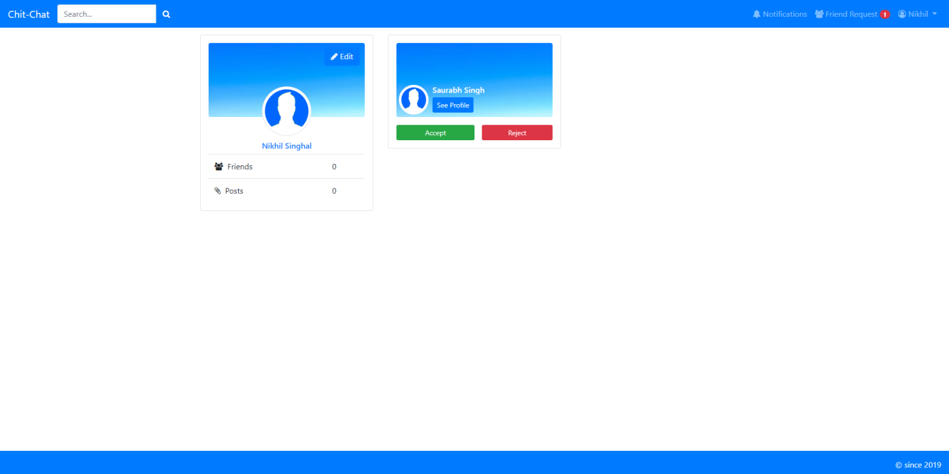

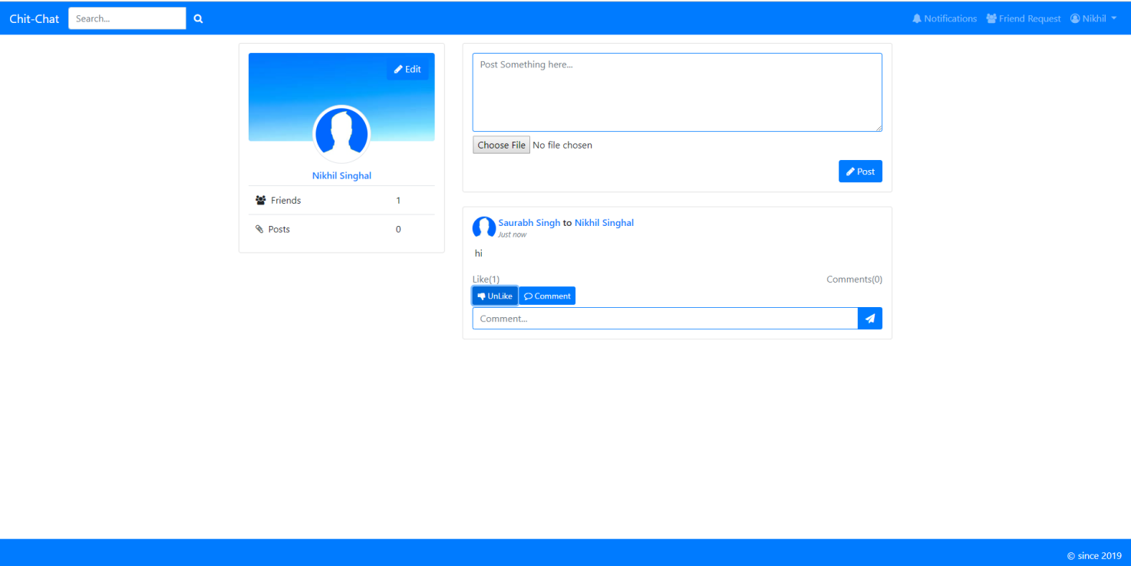

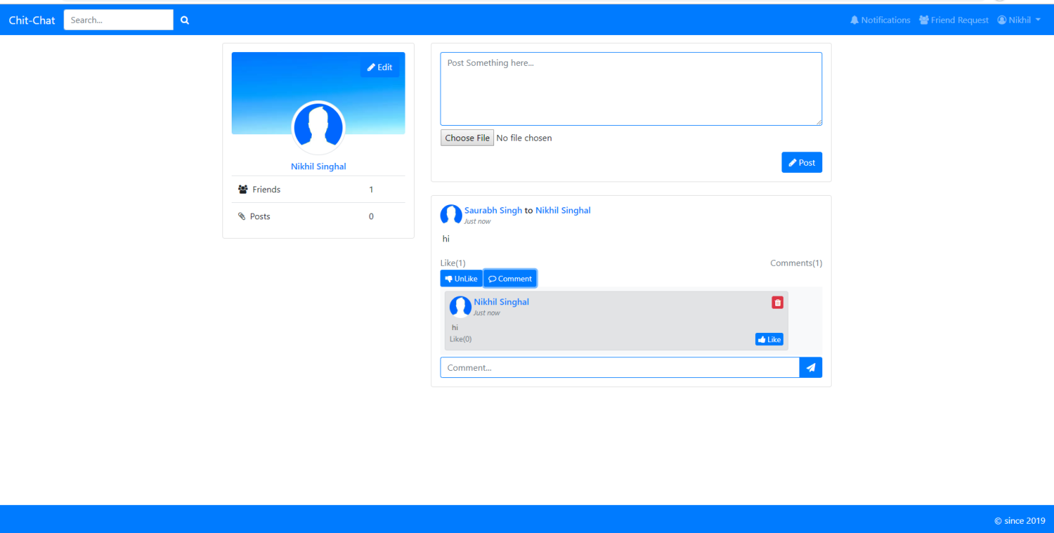

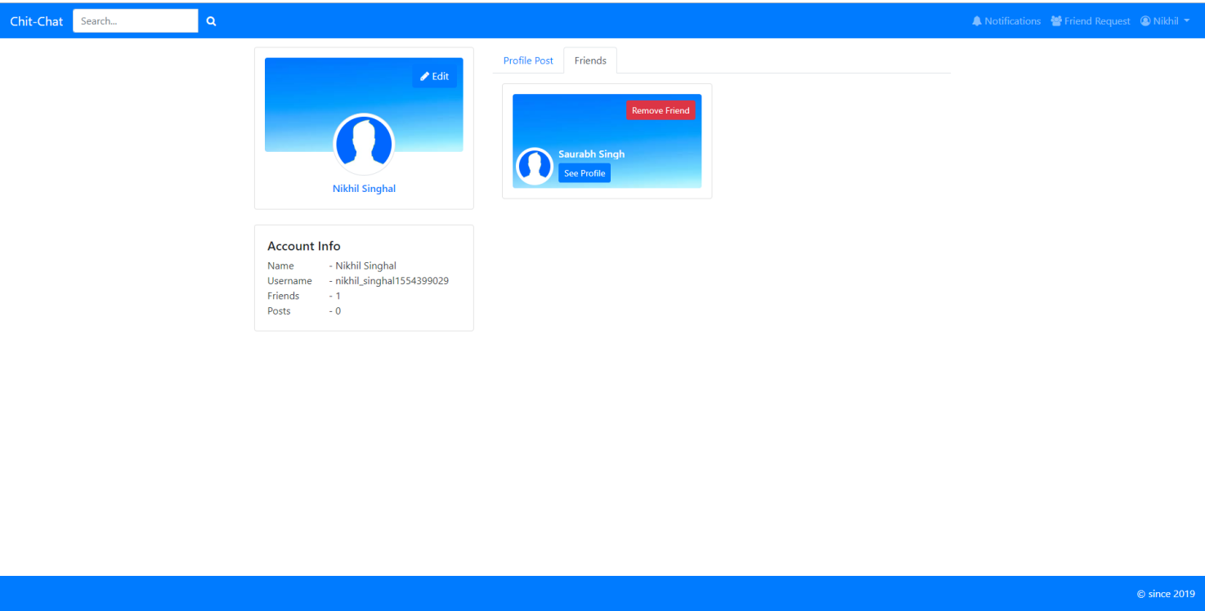

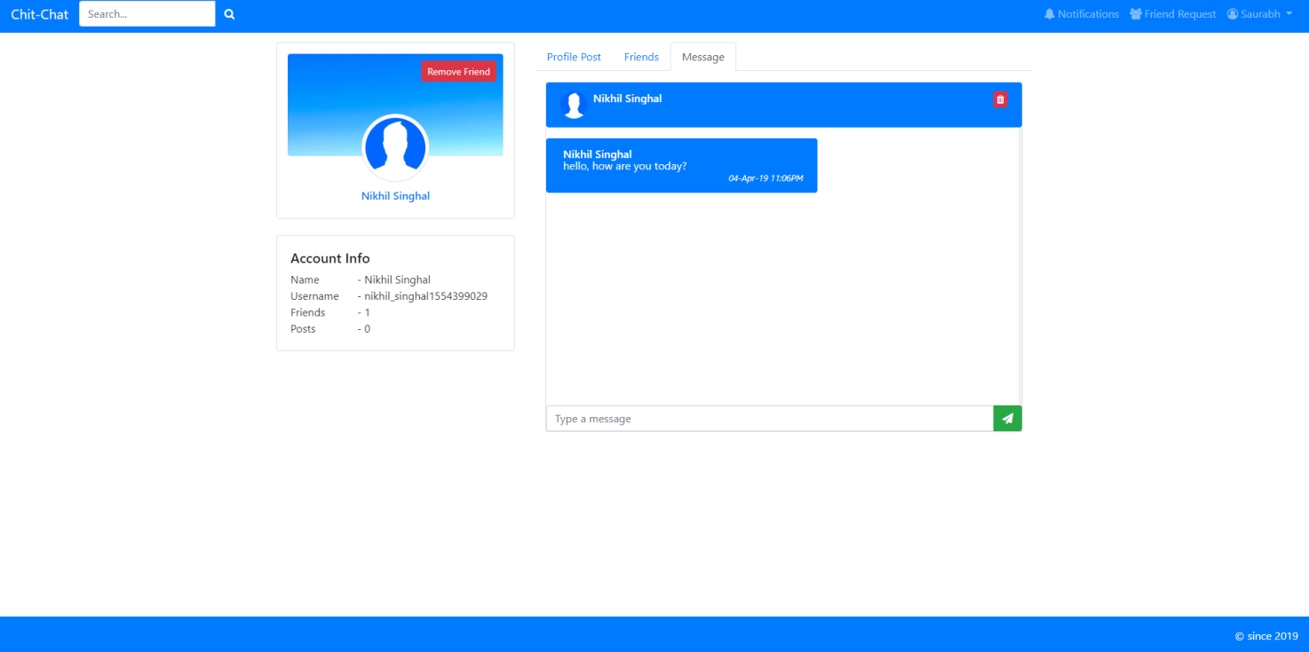

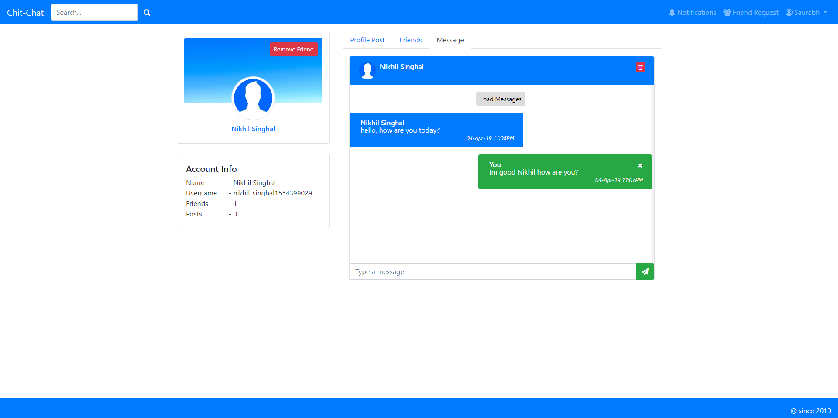

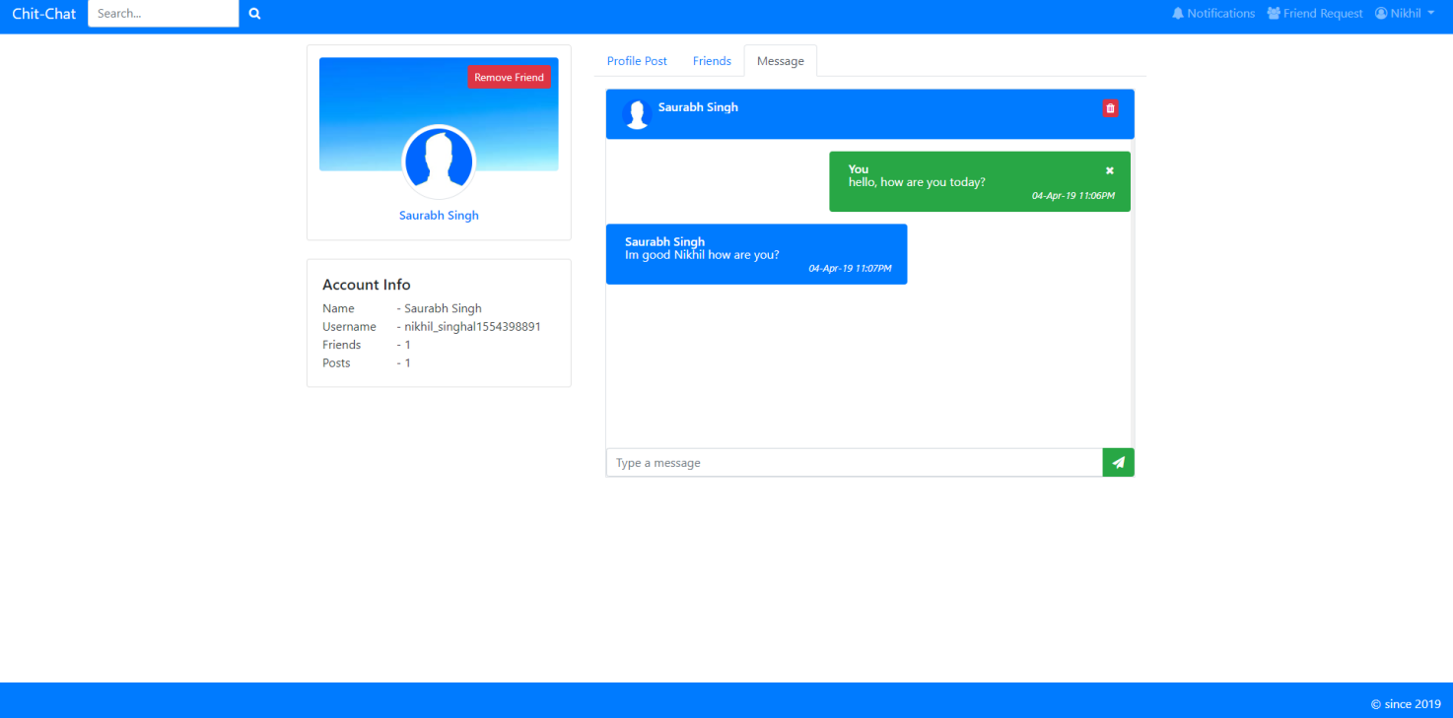

**6.Testing and Validation**

**6.1 INTRODUCTION-**

Testing is the process of running a system with the intention of finding errors. Testing enhances the integrity of a system by detecting deviations in design and errors in the system. Testing aims at detecting error-prone areas. This helps in the prevention of errors in a system. Testing also adds value to the product by conforming to the user requirements.

The main purpose of testing is to detect errors and error-prone areas in a system. Testing must be thorough and well-planned. A partially tested system is as bad as an untested system. And the price of an untested and under-tested system is high. The implementation is the final and important phase. It involves user-training, system testing in order to ensure successful running of the proposed system. The user tests the system and changes are made according to their needs. The testing involves the testing of the developed system using various kinds of data. While testing, errors are noted and correctness is the mode.

**6.2 OBJECTIVES OF TESTING:**

The objectives of testing are:

* Testing is a process of executing a program with the intent of finding errors.
* A Successful test case is one that uncovers an as- yet-undiscovered error.

**The various types of testing on the system are:**

1. Unit Testing.

2. Integration Testing

3. System testing

4. User Acceptance Testing

**6.2.1 Unit Testing:**

Unit testing focuses efforts on the smallest unit of software design. This is known as module testing. The modules are tested separately. The test is carried out during programming stage itself. In this step, each module is found to be working satisfactory as regards to the expected output from the module.

**6.2.2. Integration Testing:**

Data can be lost across an interface. One module can have an adverse effect on another, sub functions, when combined, may not be linked in desired manner in major functions. Integration testing is a systematic approach for constructing the program structure, while at the same time conducting test to uncover errors associated within the interface. The objective is to take unit tested modules and builds program structure. All the modules are combined and tested as a whole.

**6.2.3. System Testing:**

System testing is the stage of implementation. This is to check whether the system works accurately and efficiently before live operation commences. Testing is vital to the success of the system. The candidate system is subject to a variety of tests: on line response, volume, stress, recovery, security and usability tests. A series of tests are performed for the proposed system is ready for user acceptance testing.

**6.2.4. User Acceptance Testing:**

User acceptance of a system is the key factor for the success of any system. The system under consideration is tested for the user acceptance by constantly keeping in touch with the prospective system users at the time of developing and making changes whenever required.

* **Validation:**

At the culmination of the integration testing, Software is completely assembled as a package. Interfacing errors have been uncovered and corrected and a final series of software test begin in validation testing. Validation testing can be defined in many ways, but a simple definition is that the validation succeeds when the software functions in a manner that is expected by the customer. After validation test has been conducted, one of the three possible conditions exists.

1. The function or performance characteristics confirm to specification and are accepted.
2. A deviation from specification is uncovered and a deficiency lists is created.
3. Proposed system under consideration has been tested by using validation test and found to be working satisfactory.

* **Output Testing:**

After performing the validation testing, the next step is output testing of the proposed system, since no system could be useful if it does not produce the required output in a specific format. The output format on the screen is found to be correct; the format was designed in the system design time according to the user needs. For the hard copy also; the output comes as per the specified requirements by the user. Hence output testing did not result in any correction for the system.

**Login:**

|  |  |  |  |  |
| --- | --- | --- | --- | --- |
| **Sl No** | **Input Values** | **Test case** | **Conditional being checked** | **Result** |
| 1 | Email | Empty | Please Enter valid EMAIL ID OR PASSWORD | Successful |
| 2 | Password | Empty | Please Enter valid EMAIL ID OR PASSWORD | Successful |
| 5 | Password | If wrong Password | Please Enter valid EMAIL ID OR PASSWORD | Successful |

**Registration:**

|  |  |  |  |  |
| --- | --- | --- | --- | --- |
| **Sl No** | **Input Values** | **Test case** | **Conditional being checked** | **Result** |
| 1. | First Name | Empty | It must not be empty | Successful |
| 2 | Last Name | Empty | Last Name must not be empty | Successful |
| 3 | Email | Empty | Enter valid Email ID. | Successful |
| 4 | Password | Empty | Enter valid Password. | Successful |
| 5 | Password | Length | Minimum 8 characters required | Successful |
| 6 | Confirm Password | Empty | Password and confirmation password must be same | Successful |
| 7 | Date Of Birth | Select | Enter valid Username and Password. | Successful |

**Edit Profile:**

|  |  |  |  |  |
| --- | --- | --- | --- | --- |
| **Sl No** | **Input Values** | **Test case** | **Conditional being checked** | **Result** |
| 1. | First Name | Null | First Name must not be empty | Successful |
| 2 | Last Name | Empty | Last Name must not be empty | Successful |
| 3 | City | Empty | City must not be empty | Successful |
| 4 | State | Empty | state must not be empty | Successful |
| 5 | Pin code | Empty | PIN code must not be empty | Successful |
| 6 | Country | SELECT | Please select country | Successful |
| 7 | High School | Empty | High School must not be empty | Successful |
| 8 | College | SELECT | Please select college | Successful |
| 9 | Course | Empty | Course must not be empty | Successful |

**Scrap:**

|  |  |  |  |  |
| --- | --- | --- | --- | --- |
| **Sl No** | **Input Values** | **Test case** | **Conditional being checked** | **Result** |
| 1. | STATUS | Null | STATUS SHOULD NOT UPLOADED | Successful |
| 2 | Message | Null | Please enter message in text | Successful |

**Question and Answers:**

|  |  |  |  |  |
| --- | --- | --- | --- | --- |
| **Sl No** | **Input Values** | **Test case** | **Conditional being checked** | **Result** |
| 1. | Question | Null | Please add Question. | Successful |
| 2 | Options | Null | Please Enter Options. | Successful |
| 3 | Answer | Select | Please Select valid answer | Successful |

**Photos:**

|  |  |  |  |  |
| --- | --- | --- | --- | --- |
| **Sl No** | **Input Values** | **Test case** | **Conditional being checked** | **Result** |
| 1. | Image Title | Null | Image title must not be empty | Successful |
| 2 | Add Image | BROWSE | Please browse image | Successful |

**7. Non-functional Requirements**

**7.1 Performance requirements**

**7.1.1 Scalability**

System should be able to handle a large number of users. For e.g., handling around thousand users at the same time.

**7.1.2 Speed**

The application should be fast. It should not slow down with increase in the number of users. Search functionality should be fast to enable better end-user experience. The system should be quick enough to be able to respond to the user actions within a short period of time. E.g. the search user functionality of Chitchat should perform a quick search among the users on the database.

**7.2 Security requirements**

During user registration, the given email address is validated.

The password should be at least 8 characters, containing at least a small character and one capital, a number and a special character.

Password is stored as a hash value in database.

We are transferring all data via HTTPS i.e. via SSL so that the data is encrypted during the transit. Thus safe guarding the user’s information.

**7.3 Software Quality Attributes Requirements**

**7.3.1 Usability**

Chitchat User interface should be simple and clear to be able to understand by any user.

**7.3.2 Availability**

The system should be available at all times. It should be ensured that there should be minimum or no downtime to ensure better user experience.

**7.3.3 reliability**

The system should be reliable. It should yield correct results if a user performs searches for a person. Also, if the user sends Message or media, the system should ensure that the correct message is delivered to the correct destination without any loss or change in content.

**7.3.4 Testability**

The application should be testable. A separate test environment should be set up where testers and the Quality Assurance engineers can test the application for bugs and/or incomplete or missed requirements.

**7.3.5 Maintainability**

The system should be developed in such a way that it is extensible. It should be easy to incorporate new features requirements or accommodate a change in the existing requirements.

**8. CONCLUSION**

[Social Networking](http://bcu-msc-cs.wikidot.com/start) website is a revolutionary idea with a very bright future with further scope for advancements. The opportunities provided from this medium are immense and many organisations are making use of this medium to better their practices. Organisations are no longer at the mercy of the media to advertise or convey their message. With the help of social networking they can advertise or communicate in a more efficient way. For example, Starbucks have started a very successful program in which a person from any part of the world can login to a website to write comments and discuss issues. Similarly people don’t have to rely on newspapers or TV to get their daily dose of news it can all be obtained from a social networking site. People can follow or get information from any part of the world. For example Twitter allows a user to follow anything from airline timing to the next breaking news from China. It is even used by politicians to get their message across.

Online communities and Blogs are becoming very popular and moreover since the advancement of embedded systems people can use them “on the go” with the help of handheld devices like cell phones or palmtops. They can get information which is more interactive in nature with the help of embedd [photo and video](http://bcu-msc-cs.wikidot.com/photos-and-videos). Iphone is an example of a handheld device through which people can share information. People can also take part in the social network by using many tools available to them. Users can tag particular pages of interest in an interactive manner or can just [bookmark](http://bcu-msc-cs.wikidot.com/bookmarks-and-folksonomies) them for further interaction. The kind of interaction a user wants from these social networks depends on the type of information the user is interested in. Wikis can be used for academic purpose, it can greatly enhance the way people learn. People can watch videos to understand a topic better or look at photos which might help them to visualize a concept, after all “a picture speaks a thousand words”.

The world is getting closer everyday and everyone wants to be connected. Static blogs and websites are losing popularity. World is moving more towards "information streams". The information comes to users rather than users have to make effort to get the information. The social networks can be extended to other media, for example Television now integrates Twitter feeds. In terms of personal relationships too the social networking is connecting people. Dating sites have become very popular to find partners and to be connected with each other. Social networking can also be very crucial in medical help. Illness support [communities](http://bcu-msc-cs.wikidot.com/online-community) can be created from which people can get information about common diseases and also first aid tips.

After all the advantages, the problem that arises is of information overload and security. Social networks, unlike the common media, do not have a pattern as to how much information has to be conveyed and where to draw the line. Too much of information may confuse users. Security might be another area of concern where people can get illegal access to a user’s information. The future of social networking looks very promising but still it has to deal with the problems associated with it.

**9. Appendices-**

**9.1 Coding/Coding templates-**

**9.1.1 Database config code-**

**s**

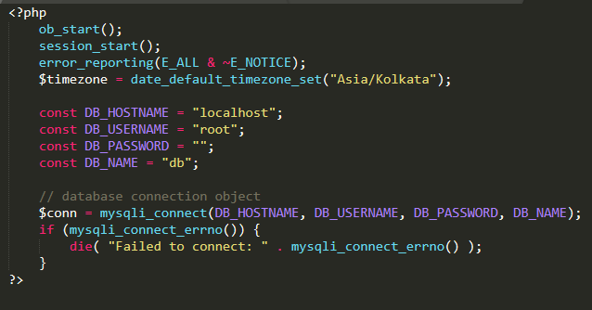

**Future Scope and Further Enhancement:**

The advantages and disadvantages of a Online Social Networking website are much the same as those for a real life. However, the effort to develop and maintain online Social Networking website is usually far less than that expended for a real life system: The most difficult problem is specifying a virtual machine which can peacefully coexist with the desired target systems. In some respects, this approach makes sense for making people communicate on web. The identification of clear-cut interfaces is a standard structured programming technique, which (in theory at least) reduces software maintenance costs. The only controversy might be over the particular choice of structure (i.e. social networking). In general, whenever organizational site is likely to outlive its hardware, the ONLINE SOCIALNETWORKING approach warrants consideration. This is because of the high redevelopment costs.

Now, when such social networking site is easily approachable to the user via website, it is easy and convenient for them to be in touch with their colleagues. It gives further opportunity to the coming users to enhance the IT technologies.

* Update website according to user requirements
* Online Games and other application
* Different types of advertisement like Auction, Discounts, etc.
* Privacy of user information among other person on network

**Definitions & acronyms-**

The following table explains terms and acronyms specific to this Report.

|  |  |
| --- | --- |
| **Term/Acronym** | **Description/Definition** |
| ChatBook | A social networking website. |
| FR | Functional Requirement |
| DFD | Data Flow Diagram |
| Team | The Group who are using this report for the project |
| Posts | Post is a post shared by the user on his slate. |
| Profile Posts | Posts by him or Profile users post |
| Messages | Chatting activity between two users |

**Bibliography**

**Books :**

* Beginning PHP5  
  Author : Dave Mercer
* PHP CookBook  
  Author : David Sklar, Adam Trachtenberg
* Mysql: The Complete Reference

Author : [Vaswani](http://www.google.co.in/search?hl=en&client=firefox-a&rls=org.mozilla:en-US:official&biw=1366&bih=624&tbm=bks&tbm=bks&q=inauthor:%22Vaswani%22&sa=X&ei=74XYTrn_E4HQrQei0KnVDQ&ved=0CDgQ9Ag)

**Websites:**

* [www.w3schools.com](http://www.w3schools.com)
* [www.php.net](http://www.php.net)
* [www.mysqltutorial.org](http://www.mysqltutorial.org)
* [www.youtube.com](http://www.youtube.com)
* [www.google.com](http://www.google.com)